Gun Review: The Marlin Golden 39A Rifle
Posted August 29, 2011 in Reviews, Rifles by Phil White with 46 Comments
Tags: 22, lever action, Marlin, rifle, rifles
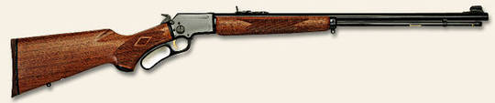
NOTE: This product review was made possible by GunsForSale.com. To get up-to-date information on where to find Marlin rifles for sale, please visit GunsForSale.com.
There has never been a rifle with a more appropriate name. This rifle is “Golden” in a lot of shooters memories. The 39 is the oldest rifle still in production . In fact when Remington purchased Marlin the 39A was the only lever action Marlin had in production until the factory geared up.
The Marlin Golden 39 started out life as the Marlin model 1891 and was used by Annie Oakley in her shooting exhibitions. It was again renamed this time the model 1897 “Bicycle Rifle”. Yep you heard it right the “Bicycle Rifle” with a canvas case for an extra $1.75 made from duck material and lined with red felt. This folks answers the question of why they made this rifle with the large takedown screw on the side. The owner would take the rifle down, place it in the canvas type case and attach the specially designed handles to the V shaped bicycle body.

Late model Golden 39A
In 1922 it was again renamed to the model 39 then finally the last change in 1939 to the model 39A, which finally stuck to this day. When first made it had a straight stock in American Walnut. Of course this rifle and all Marlin lever rifles had the highest quality American Walnut stocks. In 1946 the 39A offered a fluted comb rear stock. In 1950 a white cap was added to dress the rifle up a bit. Oh yes, the “Golden” part of the name was because of the gold colored trigger added later.
My second rifle was a Marlin 39A and a rare one at that. I doubt you’ll ever see one but we—well most of us know how popular Westerns were in the late 1940’s and 1950’s. The Rifleman was one of the most popular TV shows at the time. If you’ve ever seen the intro to the show you’ll see Chuck Conners working that lever at light speed
My early 1950’s model had an addition most people have never heard of. At the inside bottom of the lever just under the trigger was a pinned small lever that could be folded out so when the lever was worked this piece tripped the trigger automatically firing a round. As a 12 year old this was very cool! This little factory addition only lasted a few years because of liability concerns I imagine. If I had only known that rifle would still be with me.
Specifications
Action | Lever
Caliber | .22 LR / Long / Short
Capacity | 19 / 21 / 26
Finish | Steel/Blue
Barrel | 24″
Stock | American Black Walnut
Twist | 1:16″
Overall Length | 40″
Weight | 6.5 lbs
Sights | Adjustable folding rear sight. Ramp front sight, brass bead, Wide-Scan brand hood
Boys back in my youth would pickup Coke bottles and sell them back to the grocery store for a nickel a piece. We would also cut yards for a $1 if we could get that much. With these funds we would buy our .22 long rifle ammo to feed our precious rifles. Speaking of ammunition the 39A holds 19 rounds of .22 long rifle which is a good number of rounds. It would feed any type of .22 for a total of 26 rounds of “shorts”. Loading was accomplished by turning a small knob in the feed tube under the barrel towards the front that freed the brass tube allowing you to move it to the front until the bullet shaped hole was clear. Then you just dropped the rounds into the tube until you couldn’t get another round in. Push the hollow brass rod back in the tube and turn to lock and start shooting!
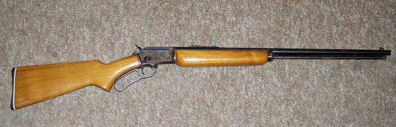
Even when I got mine for Christmas in 1961 it wasn’t cheap for the time at $75 used. Of course current prices are nearing $600 with older used guns as high as $750.
The sights are worth mentioning. They did change a bit over the years to a small degree. The rear sight is the “Buckhorn” type with elevation adjustment only. Later the front sight was notched on either side to slide a hood over the front sight to reduce glare. Sometime in the late 1950’s Marlin included a pre drilled receiver for scope mounting along with a mounting plate and two screws to attach it to the top of the receiver. Of course even as a kid this was a horrible thing since no Cowboy would ever use a scope!
Conclusion
This rifle is probably the most accurate .22 I’ve ever shot or owned. Micro-grooved rifling was added in the mid 1950’s and whether that had any effect on accuracy I have no idea but mine was super accurate. They do have a long sight radius with a 24 inch barrel. They weigh almost seven pounds that gives a bit of heft to steady the rifle. I know mine brought home its share of small game
To me it’s the last of the old forged steel rifles with real American Walnut stocks and a bit of actual hand fitting. This just appeals to me a great deal and always will. It harkens back to simpler times and guns that were almost all blue steel and high grade wood.
They are rare now and seldom seen in gun shops. In fact I haven’t seen one in years. People who own them now keep them as family heirlooms to be handed down to sons and grandsons and just maybe great grandsons. I just know these rifles are a class act with more than it’s share of history.

